**SUMMER TRAINING REPORT**

**Network Management Course**

At : IIT Kharagpur, Kolkata

Held By : Nettech Private Limited Company

Duration : June 2017-July 2017



Submitted By:

Bhawna

Roll No:161476

## Table of Contents

|  |  |  |
| --- | --- | --- |
| **Sr. No.** | **Content** | **Page No** |
| 1 | Acknowledgment | 3 |
| 2 | Declaration | 4 |
| 3 | Computer Network Management Introduction | 5 |
| 4 | Classification of Network Based on Scale | 6 |
| 5 | OSI Model | 7 |
| 6 | Network Topologies | 8 |
| 7 | LAN Technologies | 9 |
| 8 | Networking Devices | 10 |
| 9 | IP address in networking | 11 |
| 10 | Subnetting | 12 |
| 11 | IPv4,IPv6 | 13 |
| 12 | Network Protocols | 14 |
| 13 | How to make a Routing Table | 15 |
| 14 | Cisco Packet Tracer | 16 |
| 15 | Working on Telnet | 18 |
| 16 | Appendices | 19 |

# DECLARATION BY THE CANDIDATE

I the undersigned solemnly declare that the report is based on my own training carried out during the course of my study under the supervision of Dr. Swapan Purkait.

I assert the statements made and conclusions drawn are an outcome of my training lectures.

I further certify that :

1. The work contained in the report is authentic and has been done by me under the general supervision of my supervisor.
2. I have followed the guidelines provided by the university in writing the report.

Bhawna

Roll no:161476

## Computer Networking

**Introduction**

In simple terms it means an interconnected set of some objects. For decades we are familiar with the Radio, Television, railway, Highway, Bank and other types of networks. In recent years, the network that is making significant impact in our day-to-day life is the Computer network. By computer network we mean an interconnected set of autonomous computers. The term autonomous implies that the computers can function independent of others. However, these computers can exchange information with each other through the communication network system. Computer networks have emerged as a result of the convergence of two technologies of this century- Computer and Communication.

**Classification of Network Based on Scale:**

* 1. LAN:

Local area networks, generally called LANs, are privately-owned networks within a single building or campus of up to a few kilometers in size. They are widely used to connect personal computers and workstations in company offices and factories to share resources (e.g., printers) and exchange information.

Traditional LANs run at speeds of 10 Mbps to 100 Mbps, have low delay (microseconds or nanoseconds), and make very few errors. Newer LANs operate at up to 10 Gbps.

* 1. MAN:

MAN is designed to extend over the entire city. It may be a single network as a cable TV network or it may be means of connecting a number of LANs into a larger network so that resources may be shared . For example, a company can use a MAN to connect the LANs in all

its offices in a city. MAN is wholly owned and operated by a private company or may be a service provided by a public company.

* 1. WAN:

WAN provides long-distance transmission of data, voice, image and information over large geographical areas that may comprise a country, continent or even the whole world. In contrast to LANs, WANs may utilize public, leased or private communication devices, usually in combinations, and can therefore span an unlimited number of miles

* 1. The Internet:

Internet is a collection of networks or network of networks.

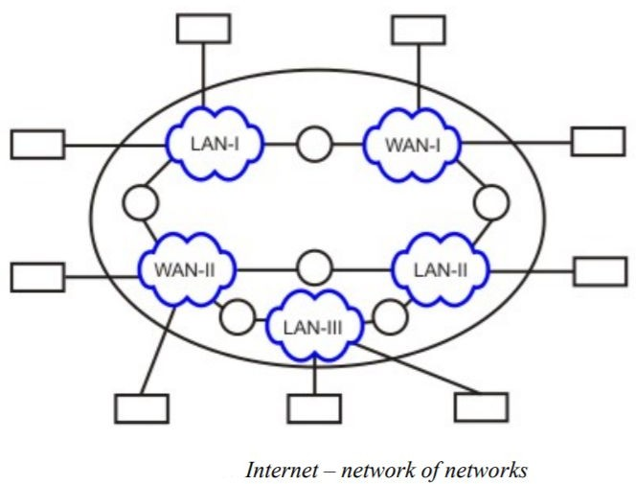

**OSI Model:**

The OSI reference model is a conceptual model composed of seven layers, each specifying particular network functions.

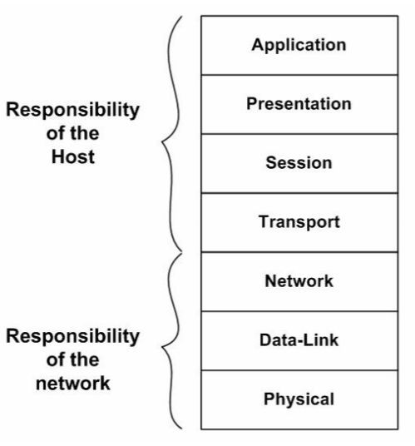7. **Application Layer**: Provides Applications with access to network services.

6. **Presentation Layer**: Determines the format used to exchange data among networked computers.

5. **Session Layer**: Allows two applications to establish, use and disconnect a connection between them called a session.

4. **Transport Layer**: Ensures that data is delivered error free, in sequence and with no loss, duplications or corruption.

3. **Network Layer**: This is responsible for addressing messages and data so they are sent to the correct destination, and for translating logical addresses and names (like a machine name FLAME) into physical addresses.

2. **Data-Link Layer**: This layer takes the data frames or messages from the Network Layer and provides for their actual transmission. At the receiving computer, this layer receives the incoming data and sends it to the network layer for handling.

1. **Physical Layer**: Controls the transmission of the actual data onto the network cable. It defines the electrical signals, line states and encoding of the data and the connector types used. An example is 10BaseT.

**Network Topologies**

Topology refers to the way the computers are connected in a network.

1. Mesh Topology:

Fully connected , Robust , Highly reliable ,Not flexible ,Poor expandability

1. Bus Topology:

Flexible , Expandable , Moderate Reliability , Moderate performance

1. Star Topology:

High Speed , Very Flexible , High Reliability , High Maintainability

1. Ring Topology:

easy fault isolation,easy to configure and install.

1. Tree Topology:

good in organisation,scalable and flexible.

**LAN Technologies:**

A LAN consists of shared transmission medium and a set of hardware and software for interfacing devices to the medium and regulating the ordering access to the medium.

A LAN enables stations to communicate directly using a common physical medium on a point-to-point basis without any intermediate switching node being required.

Limited geographical area – which is usually less than 10 Km and more than 1 m. • High Speed

* 10 Mbps to 1000 Mbps (1 Gbps) and more .

**Networking Devices**

* + Switches:

Switches are the foundation of most business networks. A switch acts as a controller, connecting computers, printers, and servers to a network in a building or a campus.Switches allow devices on your network to communicate with each other, as well as with other networks, creating a network of shared resources. Through information sharing and resource allocation, switches save money and increase productivity.

* + Routers:

Routers connect multiple networks together. They also connect computers on those networks to the Internet. Routers enable all networked computers to share a single Internet connection, which saves money.

A router acts a dispatcher. It analyzes data being sent across a network, chooses the best route for data to travel, and sends it on its way.Router is considered a Layer 3 device of the OSI model because its primary forwarding decision is based on the information of the OSI Layer 3 (the destination IP address). If two hosts from different networks want to communicate with each other, they will need a router between them.

**IP address in networking**

In networking,

* + - IP Address is short for **Internet Protocol Address**.
    - It is a unique address assigned to each computing device in an IP network.

Classes of IP address:

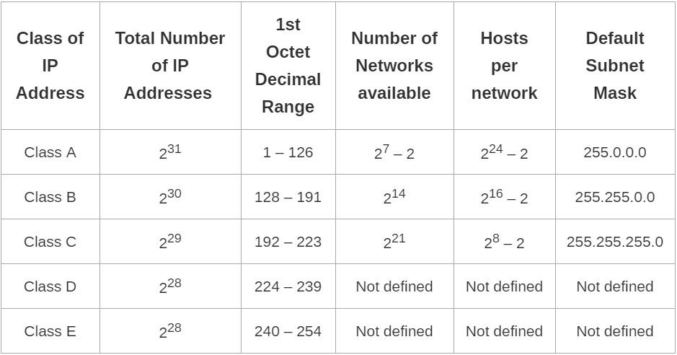

Subnetting:

All the hosts in a network must have the same network number. This property of IP addressing causes problem as the network grows. To overcome this problem, a concept known as subnets is used, which splits a network into several parts for internal use, but still acts like a single network to the outside world. To facilitate routing, a concept known as subnet mask is used.

In networking,

* + - The process of dividing a single network into multiple sub networks is called as

## subnetting.

* + - The sub networks so created are called as **subnets**.

The two main advantages of subnetting a network are-

* + - It improves the security.
    - The maintenance and administration of subnets is easy.

How to Calculate Subnet Mask?

For any given IP Address, the subnet mask is calculated-

* + - By setting all the bits reserved for network ID part and subnet ID part to 1.
    - By setting all the bits reserved for host ID part to 0.

## Example-01:

Consider a single network having IP Address 200.1.2.0 is divided into 4 subnets For each subnet-

* + - 24 bits identify the global network.
    - 2 bits identify the subnet.
    - 6 bits identify the host.

For each subnet, subnet mask is obtained-

* + - By setting the first 26 bits to 1.
    - By setting the remaining 6 bits to 0.

So, Subnet mask

= 11111111.11111111.11111111.11000000

= 255.255.255.192

## IPv4

Pv4 is a connectionless protocol used for packet switched networks. It operates on a best effort delivery model, in which neither delivery is guaranteed, nor proper sequencing or avoidance of duplicate delivery is assured. Internet Protocol Version 4 (IPv4) is the fourth revision of the Internet Protocol and a widely used protocol in data communication over different kinds of networks. IPv4 is a connectionless protocol used in packet-switched layer networks, such as Ethernet. It provides a logical connection between network devices by providing identification for each device.IPv4 uses 32-bit (4 byte) addressing, which gives 232 addresses.

**IPv6:** Although IPv4 is well designed and has helped the internet to grow rapidly, it has some deficiencies, These deficiencies has made it unsuitable for the fast growing internet. To overcome these deficiencies, IPv6 was introduced.

* IPv6 uses 128-bit address instead of 32-bit address to provide larger address space
* Uses more flexible header format, which simplifies and speeds up the routing process • Basic header followed by extended header
* Resource Allocation options, which was not present in IPv4
* Provision of new/future protocol options
* Support for security with the help of encryption and authentication
* Support for fragmentation at source

## Network Protocols:

DNS:

Domain Name Service (DNS) is an application layer protocol used to resolve hostnames to IP addresses.If you have a domain, you can get the IP address of that computer.Every address has two DNS for backup. If one goes down, other starts up .So every address has atleast minimum two DNS.

Eg: There exist a root server and the DNS server is open through port 53.

13 names of DNS server , they can have many locations.For eg:.com,.org,.in. If root goes down, internet will not run because nobody will know who is who. DNS protocol works in hierarchy:

Root

/ \

.in .com

/ \

mohit.in google.com

/ \

mail@mohit mail@google

You can have your own DNS or you can share.To check the DNS address of a server , the command C:\> ipconfig /all displays the MAC address as well as DNS address.

DHCP:

* Dynamic Host Configuration Protocol.
* If DHCP has 60 IP addresses , it is called pool.
* When it gives IP addresses , it gives it for sometime it is called least perios.
* Once ip address is given back , if asked for again one may get another, it is dynamic.
* DHCP will ask for your MAC address to find out who has the IP address.
* DHCP can reserve some static IP address for regular people.
* DHCP will not only give IP address , but also DNS,mask,gateway.
* DHCP works on broadcast .It also works on local area network.

Telnet:Telnet is an application protocol that allows a user to communicate with a remote device.

A user on a client machine can use a software (known as a Telnet client) to access a command-line interface of another, remote machine that is running a Telnet server program.

## How to make a Routing Table:

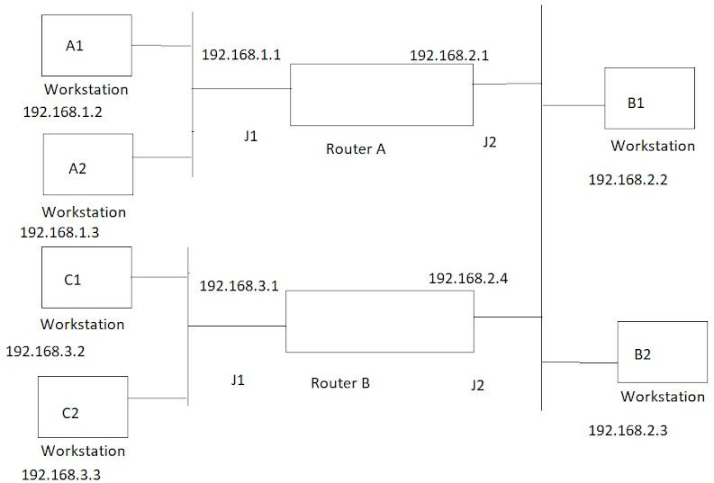

Routing Table for Router A

|  |  |  |  |
| --- | --- | --- | --- |
| Destination | Next Hop | Port | Type |
| 192.168.1.0 | 192.168.1.1 | J1 | Direct |
| 192.168.2.0 | 192.168.2.1 | J2 | Direct |
| 192.168.3.0 | 192.168.2.4 | J2(of router A) | Remote |

Routing Table for Router B

|  |  |  |  |
| --- | --- | --- | --- |
| Destination | Next Hop | Port | Type |
| 192.168.3.0 | 192.168.3.1 | J1 | Direct |
| 192.168.2.0 | 192.168.2.4 | J2 | Direct |
| 192.168.1.0 | 192.168.2.1 | J2 | Remote |

## Cisco Packet Tracer Software

Tools like Packet tracer are used for practice labs and help students to take their book learning and apply it to a real-time environment. Being able to design networks with topology elements like nodes, routers and cables teaches the user how networks are made.Packet Tracer is used by some network administrators to design networks.First we get familiar with the simulation of various devices availablel in the software like routers, switches, PC,Laptop, ethernet cable.

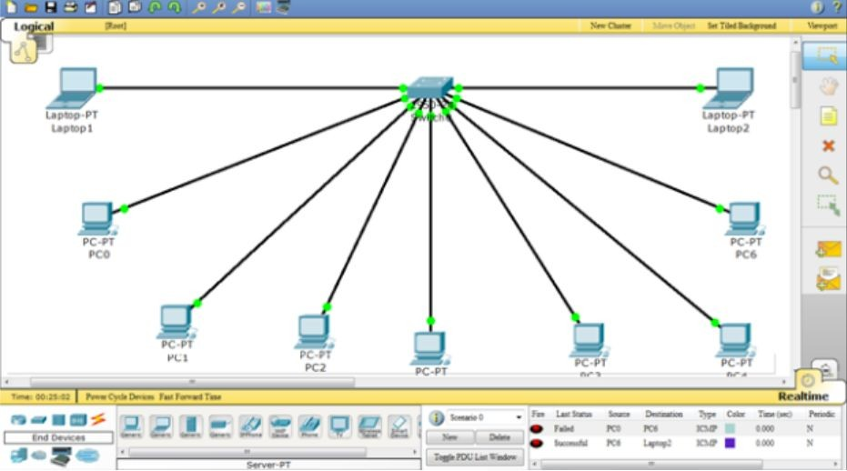

Then we need to switch on the router .

we have to repeat the process for fastethernet0/1 to activate the connection to PC1. Remember to enter a different IP address!

Configuring the gateway in the packet tracer.

The final step is to configure the gateway on each desktop computer.

Click on PC0 to view the configuration menu. Go to global sendings and find the gateway field. In the gateway field, enter the IP address of the router’s interface, which is **192.168.10.1**.

Next click the FastEthernet tab in the left-hand column to set the computer’s IP address on the network. Enter **192.168.10.2** for the IP address and **255.255.255.0** for the subnet mask.

Repeat the process for PC1 but use **192.168.20.1** for the gateway address, **192.168.20.2** for the IP address, and **255.255.255.0** for the subnet mask.

To confirm that the network works you can send packets from PC0 to PC1 and PC1 to PC0. To do this you need to click the packet icon (the envelope icon) from the menu on the right handside of the screen:

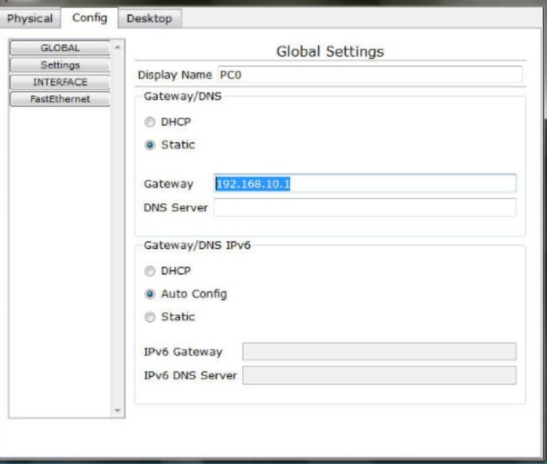

To confirm that the network works you can send packets from PC0 to PC1 and PC1 to PC0. To do this you need to click the packet icon (the envelope icon) from the menu on the right hand side of the screen.

**Working on Telnet:**

cat/etc/passwd-To list the number of users cat/etc/group-To know group of user

cat/etc/shadow-to know the encrypted password of users

userdel apple - by this the user wont be deleted from home directory rm -rf apple - this will remove user from home directory

groupadd india- to add user apple:X:501:501::/home/apple/bin/bash usermod -g fruit apple - To delete primary group usermodm -G juice apple- to add apple to juice

login as mango , to switch to user mango : su -mango mkdir ccd- to make a directory

absolute path: cd /home/mango/ccd/coffee To see a directory udisha

ls -l udisha

drwxrwxr where r- read, w-write, x- execute To change permissions

chmod 700 udisha drwx------

chmod 007 udisha

d rwx

chmod 775 bag drwxr-x---

Question: three users arthos,pothos and aramin should have full access in their own home folder and others should have read /view access.

groupadd friend useradd -G friend arthos

useradd -G friend pothos useradd -G friend aramin cd /home

chgrp friend athos chgrp friend pothos chgrp friend aramin chmod 750 athos

chmod 750 pothos

chmod 750 aramin

# References

1.Data Communication and Networking by Behrouz A. Forouzan 2.Computer Networks by Andrew S. Tanenbaum.